Dear Saint Martin’s Community, August 14, 2025

In celebration of Saint Martin’s University receiving the Colleges of Distinction accolades, the Office of Marketing and Communications is excited to share some logo and badge options for you to add to your email signature. If you prefer, you can instead use our full email signature template.

Pages 3 & 4 of this document provide the instructions of how to create an email signature within Outlook.

**LOGO/ACCOLADES PNG BLOCKS**

Choose one to copy and paste to the bottom of your email signature

**MAIN ACCOLADES**



**ALTERNATIVE ACCOLADES**

**For Specific Schools/Centers**









**FULL SIGNATURE BLOCK**

Can be copied and pasted as your email signature,

but be sure to **TYPE IN YOUR CONTACT INFO** instead of Marty’s.

**FULL EMAIL SIGNATURE EXAMPLE**

|  |
| --- |
| **Saint Marty**  **School Mascot**  Saint Martin’s University – Office of Marketing and Communications  **A:** 5000 Abbey Way SE, Old Main 299, Lacey, WA 98503  **P:** 360-688-0000 | **W:** [www.stmartin.edu](https://www.stmartin.edu/) | **E:** [smarty@stmartin.edu](mailto:smarty@stmartin.edu) |
|  |

**Create and add an email signature in Outlook (PC Instructions)**

* **Create a new email** message by clicking on the “New Email” button or using the shortcut Control-N
* Click on the **Signature button** above your email and select the menu item “Signatures…”
* Click on the **New button** to create a new signature
* Provide a name for this new signature in the window when prompted
* Within this Word document, copy the full email signature provided by **selecting the entire table** it’s within by hovering over the signature until a cross with arrows appears in the upper left corner of the signature, as seen below. Click on that cross and the entire signature should be highlighted within the table. Select Control-C to copy that signature.

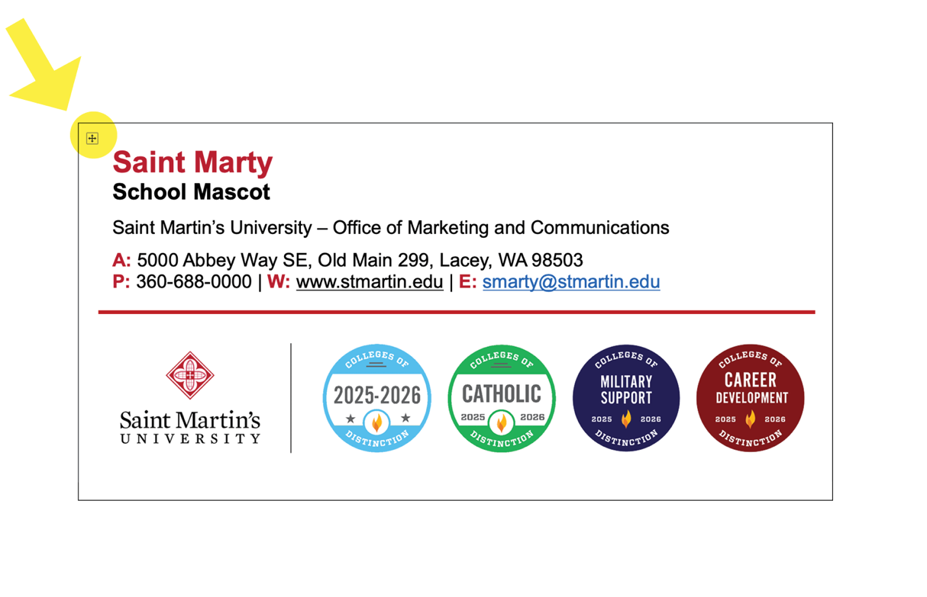

* Back in Outlook, within the open signature box, type Control-V to **paste the signature** within that box.
* Within the signature, **replace the text with your contact info**, replacing the fake info for Marty. To ensure the font and size remain the same, for text you are changing, place cursor at end of line of text and delete and retype.
* Click **OK** to save the signature.
* You can now set this as your default signature (in the same box where you edited the signature) or select it for individual emails.

**Create and add an email signature in Outlook (Mac Instructions)**

* **Create a new email** message by clicking on the “New Message” button or using the shortcut Command-N
* Click on the **Signature button** above your email and select the menu item “Manage Signatures”
* Click on the **+ button** to create a new signature
* Delete the default text that appears (usually your name)
* Within this Word document, copy the full email signature provided by **selecting the entire table** it’s within by hovering over the signature until a cross with arrows appears in the upper left corner of the signature, as seen below. Click on that cross and the entire signature should be highlighted within the table. Select Command-C to copy that signature.



* Back in Outlook, within the open signature box, type Command-V to **paste the signature** within that box.
* Within the signature, **replace the text with your contact info**, replacing the fake info for Marty. To ensure the font and size remain the same, for text you are changing, place cursor at end of line of text and delete and retype.
* Name the Signature and Save it.